UI User Analysis

Hospital Management System

Name: Alagu Soundarya G

Roll No: CB.EN.U4CYS21005

Team Number: 21

****************************************************************************************

This is webpage is designed for both doctors and patients. It is designed in such a way that it can be accessible from any place using correct login credentials

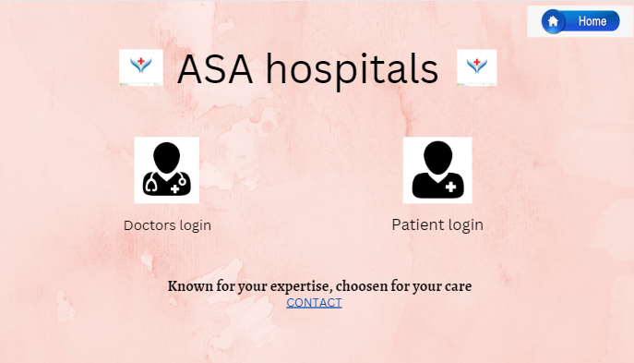

By clicking Doctors login, doctors can go to their login page and by clicking patients login, patients can go to their login page.

Here contact option is given to contact the admin officer of the hospital through call or message for any emergency purpose and doubt clarifications.

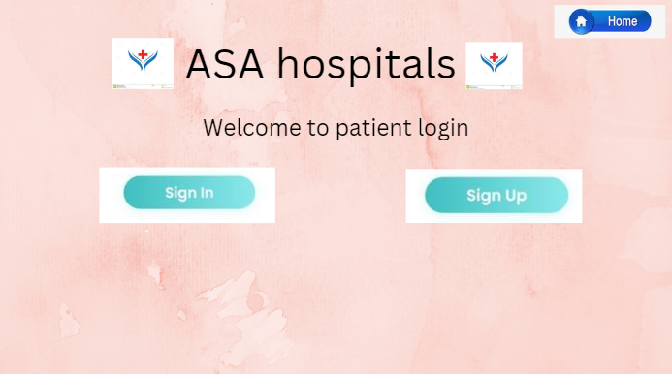

By clicking sign in user can able to access his/her medical track only by giving correct login credentials.

New patients can access this webpage by clicking sign up option

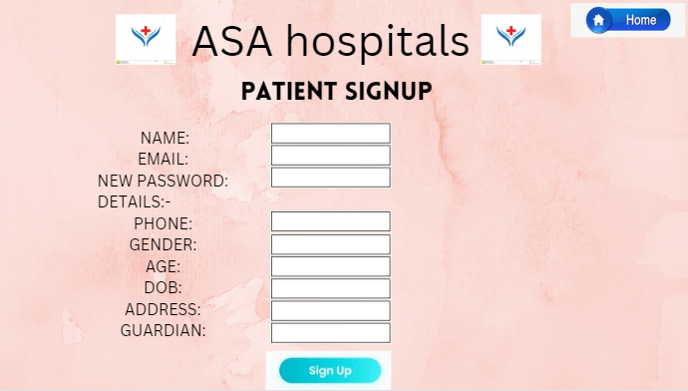

New patients can easily register by giving their needed personal information and click sign up. After signing up it will take to sign in page.

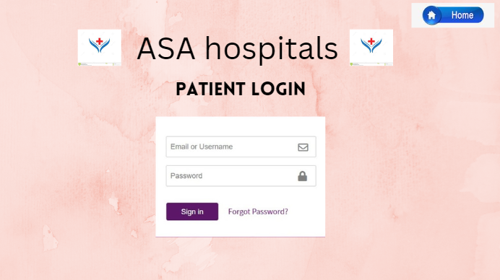

Registered patients can access this by giving proper username and password.

In case if user forgot his/her password she/he can easily change the password by giving forgot password.

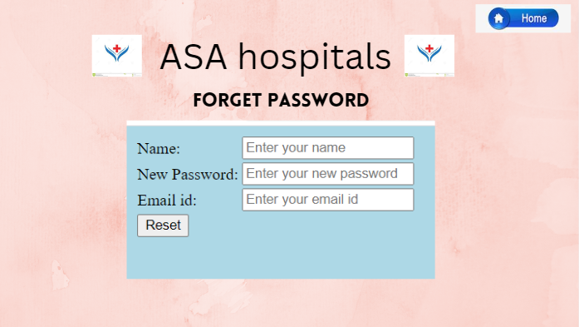

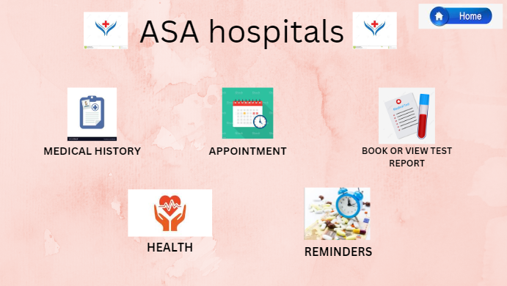

* By clicking **medical history** patients can view his/her medical history.

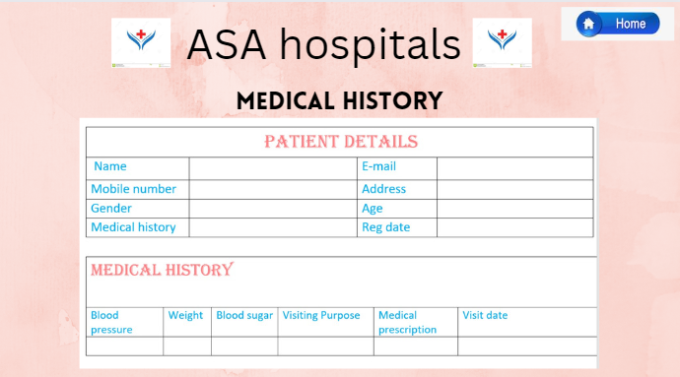

Medical history contains patient’s personal details, bmi, purpose and date of their visit to the hospital and the medicines prescribed by the doctor.

* By clicking appointment user can easily book an appointment with doctor

Patients will have option for rating in which the patients can rate the doctor( like how he/she attended the patient, how good and soft he was, does doctors prescription made the patients cure fastly.)

Before booking an appointment, patients can also view doctor’s profile. Doctors profile will have their name, specialization and rating.

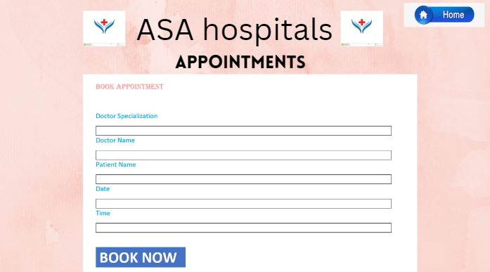

And appointment history also can be tracked

Patients can book their appointment with the specialized doctors by giving the details

* By clicking book/view test report patients can view their test reports or book for a new report.

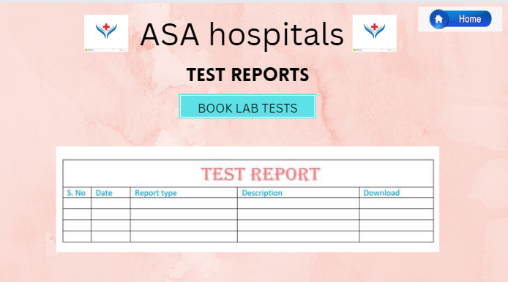

Here patients can view their reports by downloading it. Report type consists the details of what test has been taken and description of the test will be shown in description box. Patients can download it anytime.

For taking new tests user can book it online by clicking book lab tests option.

* By clicking **Health** patients can view his/her daily activities.

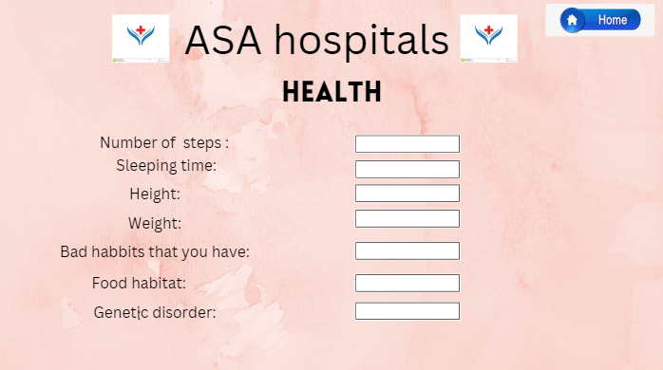

In this, patients can view how many steps they walked, their sleeping time.

* By clicking **Reminder** patients can set reminder for appointment, taking tablets at correct time etc,

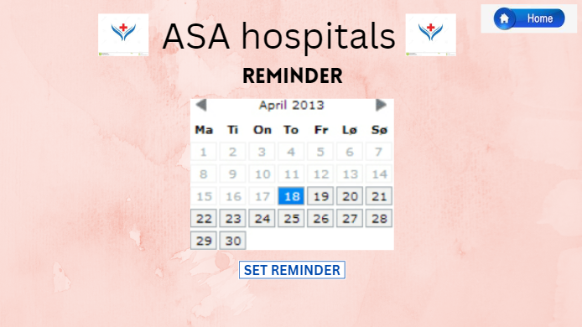

Reminder will remind the patient at the correct date and time by and will show the purpose of reminder. This will be very helpful for aged people and people who have remembrance issues.

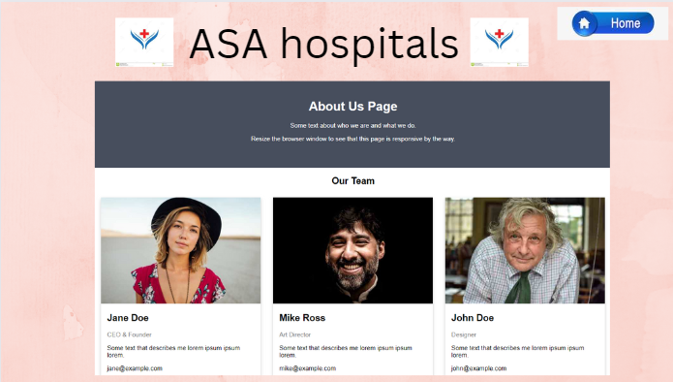

About us page has details of the chief offices and doctors of the hospital and their details

In similar way doctors also have sign in and sign-up page.

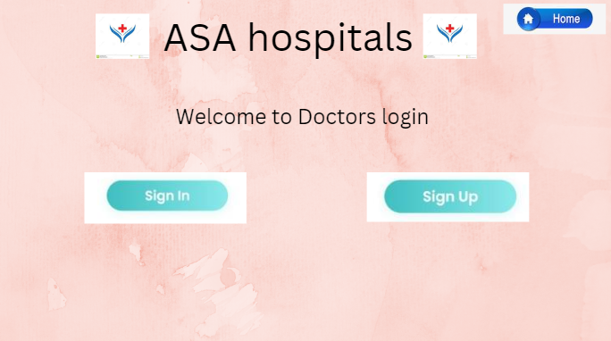

Doctors who are already working in the hospital can login to the page by giving their correct login credentials

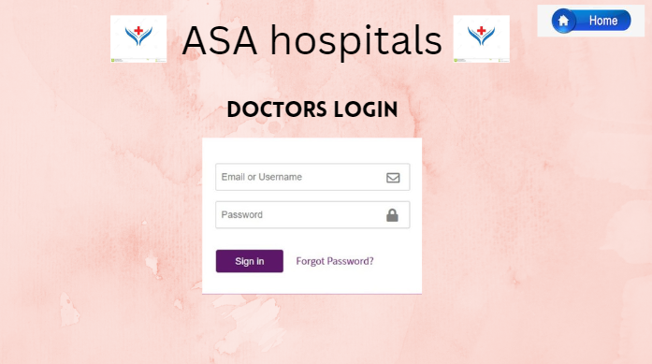

New doctors who are joining the hospital can sign up by giving their correct biodata.

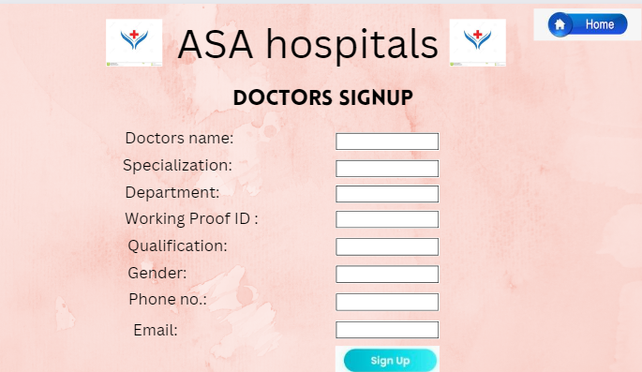

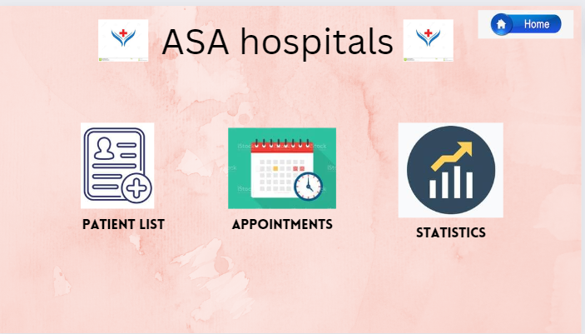

**\*\*\*\*\*\*\*\*\*\*\*\*\*\*\*\*\*\*\*\*\*\*\*\*\*\*\*\*\*\*\*\*\*\*\*\*\*\*\*\*\*\*\*\*\*\*\*\*\*\*\*\*\*\*\*\*\*\*\*\*\*\*\*\*\*\*\*\*\*\*\*\*\*\*\*\*\*\*\*\*\*\***

Doctors will have patients list which consists of patients name, age, DOB, BMI, last visit, purpose of visit and medicines prescribed.

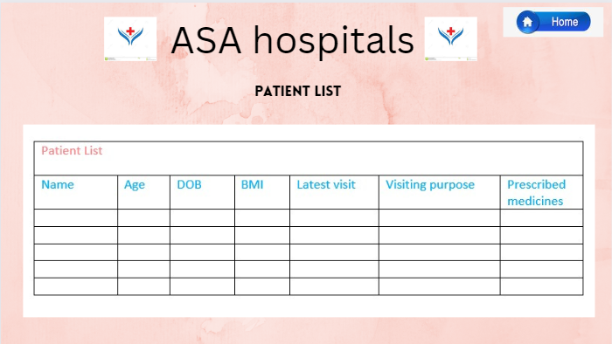

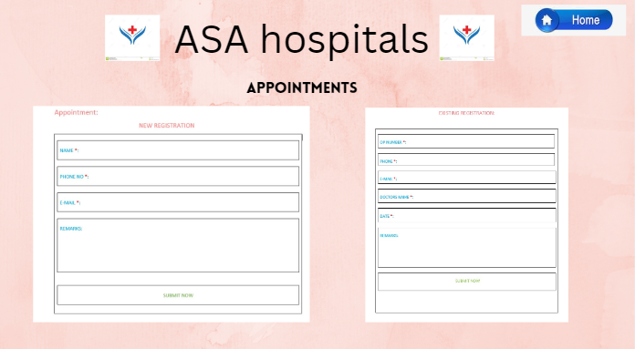

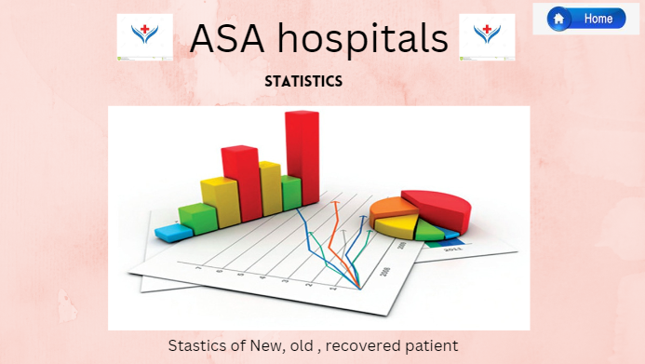

Doctors will also have the list of new patients, old patients and patients who completely got cured.

Doctors will have access to view their patients details by giving patient’s name and can have track on medical history of the patient.

Doctors will also have reminder option for reminding them for the upcoming surgery. This reminder will also give the full medical details of the patient who is going to undergo the surgery.

Reminders will daily show how many appointments the doctor has and the timing with patient details.

In case if the doctor is not available on the day of surgery due to any unfortunate reason, he/she can appoint other suitable doctors online which will send a reminder and call to the respective doctor and alert the doctor to attend the patient. That reminder message will have the whole medical track of the patient (sent by the actual doctor to the duty doctor).

Doctor will also have health option in which he/she can track their daily activities.

